About 

The QuickUSB® family of products are specifically designed to make implementing a USB 2.0 peripheral function as easy as possible. They include everything required to perform communication of the USB from your host computer. With QuickUSB, you don't have to write lower level routines like firmware, drivers or DLLs. You simply write software to call the QuickUSB Library function calls and connect your hardware to the QuickUSB Plug-In module or the USB microcontroller.
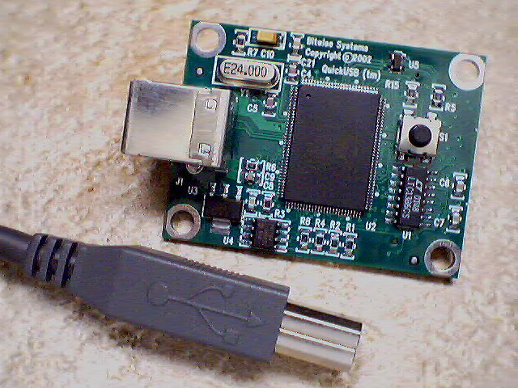
Figure 1 - The QuickUSB Plug-In Module
QuickUSB exposes all of the I/O interfaces present on the Cypress EZ USB FX2. And the QuickUSB Library is divided into sections to control each interface.

